
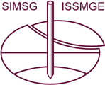
TECHNICAL COMMITTEE TC207 ISSMGE
Croatian Geotechnical Society
www.hgd-cgs.hr

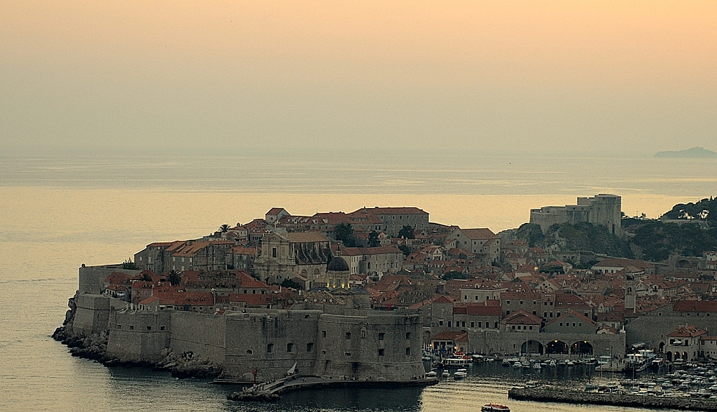
are inviting you to:

TECHNICAL MEETING TC207 – WORKSHOP
ON SOIL-STRUCTURE INTERACTION AND RETAINING WALLS

Bulletin no.1

Valamar Dubrovnik President Hotel, October 5-8, 2011, Dubrovnik, CROATIA

INVITATION

After the reorganization of the Technical Committees of the International Society of Soil Mechanics and Geotechnical Engineering (ISSMGE), the Technical Committee TC38 “Soil-Structure Interaction” was renamed as TC207 ‘’Soil-Structure Interaction and Retaining Walls’’. This Committee is gathering leading international geotechnical specialists who are making an effort to improve the knowledge of a very specific and fast growing geotechnical field. The announced meeting would be a great opportunity for them to exchange their knowledge and experience, and to present their contributions to the Committee main tasks.

The Croatian Geotechnical Society is honoured to invite members of TC207 and all those who are interested to participate in the Technical meeting and workshop of TC207 ‘’Soil-structure Interaction and Retaining Walls’’, which will take place on 5-8 October 2011 in Dubrovnik, Croatia.

The meeting and workshop is organised by the Technical Committee TC207 “Soil-structure Interaction and Retaining Walls” ISSMGE and the Croatian Geotechnical Society ‘’Hrvatsko geotehničko društvo’’ (HGD).

OBJECTIVES

The main objectives of the meeting and workshop are to provide the opportunity for members of the Technical Committee TC207 as well as other members of ISSMGE:
- To present contributions in the field of soil-structure interaction and retaining walls analyses, and
(2) To discuss their contributions to the main tasks they are engaged on:
1. Guidelines on Soil-structure Interaction. 2. Retaining Walls. 3. Website of TC207
(3) To discuss the plans for future work of TC207
STEERING COMMITTEE

Prof. Vladimir Ulitsky, Email: ulitsky.vladimir@gmail.com
Dr. Michael Lisyuk, Email: Lisyuk@gmail.com
Prof. Antun Szavits-Nossan, Email: szavits@grad.hr
Dr. Igor Sokolić, Email: isokolic@grad.hr

PROGRAMME OF THE MEETING

1. Organizational Session
Report of TC 207 Activities and plans of actions of TC207
Speaker: TC207 Chair Prof. V. Ulitsky

Report of leaders of 3 Task Forces
Task Force 1. C. Shashkin and C. Haberfield
Task Force 2. Yasser El-Mossallamy
Task Force 3. M. Lisyuk
Discussions. Plans for future work.

2. Scientific programme
Main sessions:
(1) Aspects of soil-structure interaction in design of buildings and geotechnical structures.
(2) Retaining walls and structures
(3) Failures of geotechnical structures.

More detailed programme with time schedule will be announced in the Bulletin 2.

CALL FOR PAPERS

The papers submitted by the Authors will be published on CD.
Please prepare and submit your contribution using the attached template and instructions for preparation of papers.
Please send your paper typed in this template by e-mail to lisyuk@gmail.com with a copy to isokolic@grad.hr .

VENUE AND SCHEDULE

The Meeting will be held at the Hotel Valamar Dubrovnik President****.
The tentative Schedule of the meeting is:
- 5th October – arrival to Dubrovnik
- 6th October – working day
- 7th October – working day
- 8th October – tourist tour, departure
Other dates of arrival / departure are possible for each participant

SOCIAL PROGRAMME

The social programme of the meeting includes the gala dinner on Friday evening (7th October) and a tourist tour of the Dubrovnik Old Town on Saturday morning (8th October). Dubrovnik is not just a Croatian treasure but one of the world’s treasures, a fact that was officially recognised when the United Nations declared it a World Cultural Heritage site. The tourist tour will be a great opportunity for all participants to explore this treasure.

REGISTRATION AND FEES

The participation in the meeting is free of charge for all participants, but requires registration. To register for the meeting please follow the instructions in the Registration Form. It is essential to enter your e-mail address, your address details and to indicate whether you will participate in the gala dinner on Friday evening and the tourist tour on Saturday Morning. Refreshments during the breaks are free of charge for all registered participants while the tourist tour is free of charge only for TC207 members and invited persons.

Please note that the number of participants for this special event is limited to 50, so early registration is recommended (TC207 members will have the priority before 1st August). After registration, participants will get a confirmation of their registration by e-mail.

There is a special arrangement with the Hotel Valamar Dubrovnik President for the meeting participants to get discounted prices for lunches and dinners during the working days, the gala dinner on Friday evening and the lodging. The respective prices are indicated in the Hotel Reservation Form. All correspondence on lodging and meals should be directed to the Hotel Valamar.

NOTES

The official language of the event and correspondence will be English.

DEADLINES

Submission of papers: 15 August 2011
Acceptance of papers: 31 August 2011
Registration: 1 September 2011
Hotel Reservation: 24 September 2011

CORRESPODENCE

All further information can be received from:
Dr. Igor Sokolić, civ.eng.
Faculty of Civil Engineering, University of Zagreb,
Kačićeva 26, HR-10000 Zagreb, CROATIA
Email: isokolic@grad.hr
Tel: +385 1 4639 618

