Dear colleagues!

With the support of the City Administration, the 15th World Conference of the Associated research Centers for the Urban Underground Space will be held in Saint Petersburg, Park Inn By Radisson, September 12-15, 2016. Association of Underground Builders organises the Conference on behalf of Associated research Center for the Urban Underground Space (ACUUS), with PRIMEXPO, part of ITE Group, that organizes the largest congress and exhibition events in northwest Russia, being the Conference official operator. The main theme of ACUUS 2016 is Underground Urbanisation as a Prerequisite for Sustainable Development.
ACUUS Conference is the worldwide event in the field of underground construction. This Conference has been held for the last 30 years in different cities at the highest level.
ACUUS 2016 will serve as a platform for recognized experts in the field of underground urbanism, investors, representatives of the authorities and public organisations.

The Scientific Committee members are from 18 countries of the world, 32 specialists in total. About 160 papers on underground planning and construction are planned to be presented at the event. Representatives of the following countries expressed their intention to participate in the Conference: Russia, Spain, Taiwan, Switzerland, China, Singapore, Finland, the USA, Iran, Greece, Japan, The United Kingdom, South Korea, Canada, Austria. The expected number of participants is more than 500. The official language is English.
On behalf of the Organising Committee, we invite you to participate in the 15th World Conference ACUUS 2016. Whether you would like to participate as conference visitor or speaker it is necessary:
1. To fill the registration form at www.acuus2016.com. Please start by clicking “Registration” button.
2. To receive confirmation from the Secretariat of the Conference. In case you did not, please contact the Secretariat via e-mail at info@acuus2016.com
3. To pay the registration fee.
If you plan to participate with the presentation, you will first need to send your abstract for the review before February, 28.
It is possible to submit your abstract via your personal account at acuus2016.com, login and password will be sent to you after your registration is completed. Please note the requirements of the ACUUS 2016 Conference before submitting your text:
Abstract should include the name of the paper, name and family name of the author(s), organization/company, content and main conclusions of the paper. It should not be longer than 300 words, the text should not include formulas and links. The language is English. We expect the Word file (.doc, .docx).
In case the Scientific Committee approves your abstract(s), the confirmation will be sent to the provided e-mail, you will receive the possibility to submit the full-paper. The requirements for the full-paper submission you may find in the Attachment 1 or on the website.

Deadline for abstracts submission - 28.02.2016
Deadline for full-paper submission - 30.04.2016
Printed in the proceedings papers will be indexed by SCOPUS. The full-paper text should be submitted in English or in English and Russian.
Only papers approved by SCOPUS editors will be printed in the SCOPUS proceedings. The Organising Committee of the ACUUS 2016 Conference shall not be liable in case the paper does not meet the requirements of SCOPUS.
On behalf of the Organizing Committee ACUUS 2016 I invite you to become the participant of official and social parts of the Conference, present your paper or send it for printing in the proceedings. I am certain, that our joint efforts will lead to the strengthening of the underground urbanisation role for sustainable development of the modern cities and allowing us to convince the cities administrations in necessity of the more wide approach to the underground space use.
Attachment №1 Full-paper submission guidelines

Looking forward to efficient cooperation,

ACUUS 2016 Organizing Committee Chairman  Association of Underground Builders general director | 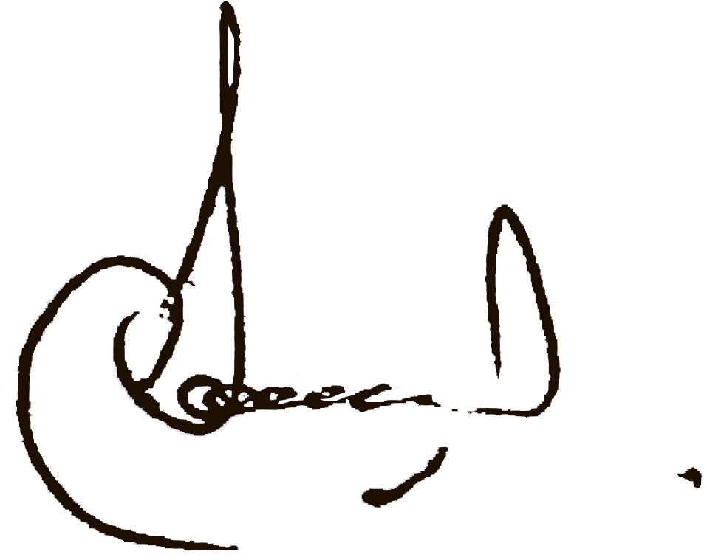 | Sergei Alpatov
Contact: Alexandra Kiseleva +7 (812) 3806005, info@acuus2016.com

