- HEADING: GENERAL REQUIREMENTS
ABSTRACT: Authors should follow these guidelines to prepare their papers for the meeting of TC207 ‘Soil-Structure Interaction and Retaining Walls’ on October 5-8, 2011 in Dubrovnik, Croatia. Please type your paper into this template.
In this frame please type the abstract of 100-120 words. Please do not try to change the size of this frame even if your abstract is comparatively short.

General Instructions for Preparation of Papers for Technical Meeting TC207 and Workshop on Soil-Structure Interaction and Retaining Walls

A.B. Author1 & C.D. Author2
Affiliation, E-mail
E.F. Author3
Affiliation, E-mail

Dear authors, we are happy to welcome you to the meeting and workshop of TC207 ‘Soil-Structure Interaction and Retaining Walls’.
Please follow the rules outlined below to facilitate publication of the CD with the Proceedings of the meeting.
Authors should limit the size of their papers to 6 pages. For the main text use Times 10 point size font with 11 point line spacing. Do not use any other font. For figure captions, references and tables please use 9 point size font. To provide uniformity of style please avoid using bold and italics and never underline any text. Never change the size of the abstract or author frames.
Always create headings, subheadings, main text, tables, figure captions and references with the appropriate styles.
  - Subheading: equations
For equations please use the Equation editor. Equations should be placed to the left of the column with no indentation. Equation numbers should be placed in parenthesis at the end of the line to the right of the column.
To refer to equations in the main text, use the following style: Equation (1) or (Eq. 1).
For example:
$η(a)=η_{∞}+(η_{0}−η)e^{−γ\frac{a}{g}}$, (1)
where η₀ and η are the initial and final values of coefficient of viscosity, respectively, a – acceleration of soil vibrations; g – acceleration of gravity.
Please do not use Equations editor for equations in the text. Use subscript and superscript options instead, for example A=(C+D)^{n}.
  - Figures and photographs
All the figures and photographs should have 300 dpi resolution. They should be pasted into the paper and sent separately as well. All graphs, pictures and photographs can be in black and white, or colour, with the good contrast. Avoid using thin lines in graphs, and the graphs with grey lines or.
Photocopies from books or journals, as well as photocopies of photographs and screened photographs should be of high quality.
Place figure captions with the given style right below the figure. Leave one line of space between the figure caption and the text.

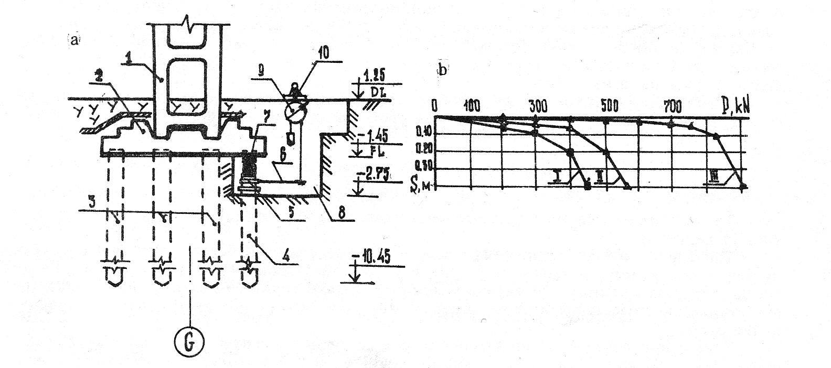
Figure 1. RC piles test results

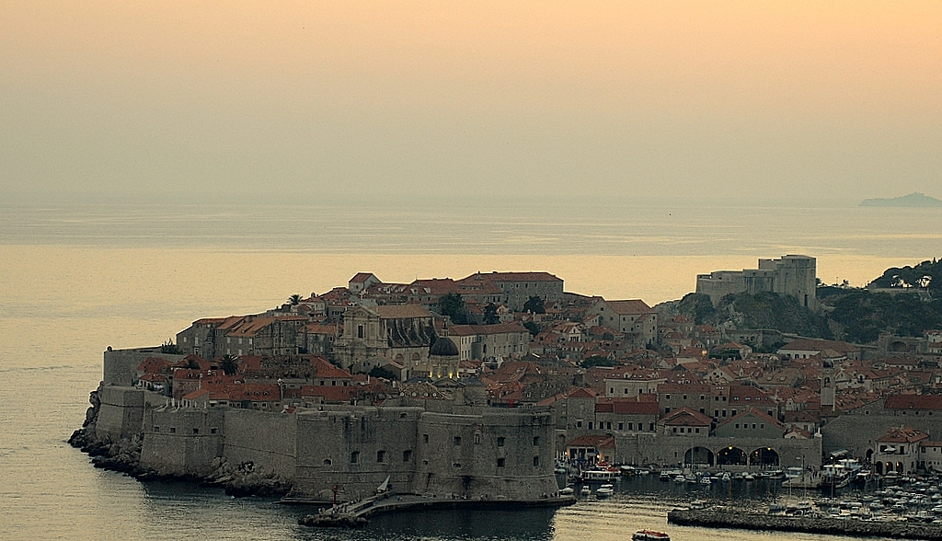
Figure 2. Dubrovnik - venue of TC207 meeting

  - Tables
For creating tables use the pattern shown below.

Table 1. Parameters of the non-linear model
Soil  Type | λ | A_{n} | K_{o} | L_{e}
Stiff clay | 0.1245 | 0.20 | 0.33 | 0.35
Sand | 0.0871 | 0.29 | 0.25 | 0.27
Peat | 0.0632 | 0.18 | 0.51 | 0.21

Leave one line of space between the table or the figure caption and the following text.

- REFERENCES
Last name, Initials, (ed.) year. Book title. City: Publisher.
Last name, Initials year. Title of article. Title of Journal, volume number, issue number, page numbers.
Use the above format for references. Put references at the end of your paper in alphabetical order. If you mention several works of the same author arrange them consecutively in chronological order.

Examples:
Barden, L. 1970. Consolidation of clay with linear viscosity. Geotechnique, Vol. 15, No. 4, pp. 345-362.
Yin, I.-H. & Graham, I. 1999. Elastic viscoplastic modeling of the time-dependent stress-strain behaviour of soils. Can. Geotech. Journal, Vol. 31, No. 1, pp. 42-52.

- paper submission
The Authors are requested to send the papers in PDF and Word format.
Please send your paper typed in this template by e-mail to lisyuk@gmail.com with a copy to isokolic@grad.hr .

